Eucharistic Procession
Feast of Corpus Christi, 2026
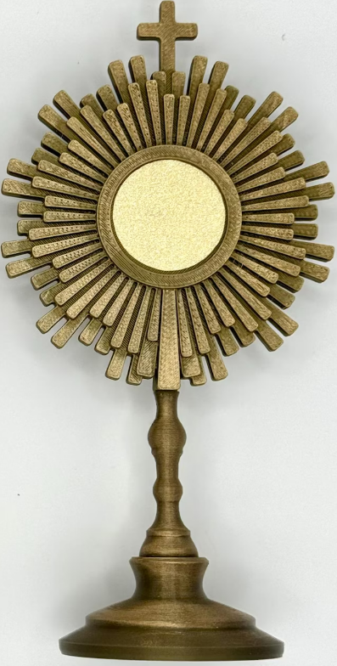

St Joseph’s Church, Northwood
Station 1 – prayer garden
Our Father, on this blessed Feast of Corpus Christi, we gather to honor the Body and Blood of Christ. May our hearts be filled with gratitude for this sacred gift. Strengthen our faith, unite us in love, and inspire us to serve others as we celebrate Your divine presence among us.
Amen
May we always cherish this sacred mystery and grow in faith, reflecting Your light in the world.
Amen.
May our hearts be ever open to the grace and love that flows from this holy mystery.
Strengthen our faith, deepen our reverence, and unite us in Your body, that we may reflect Your light in the world.
Amen.
Fill us with Your divine wisdom and grace, that we may grow in faith and love.
Nourish our spirits with Your Word, and guide us on our journey toward deeper communion with You.
May we find strength in Your presence and be renewed each day.
Amen
Lord Jesus, we humbly invite You into our hearts, seeking Your presence to fill us with love, peace, and guidance.
May Your light shine within us, transforming our thoughts and actions.
Amen.
May this sacred communion deepen our faith, unite us in love, and inspire us to live as Your hands and feet in the world.
Help us to honor this holy mystery with reverence and gratitude.
Amen
Station 2 – front of church near lilacs

Mark 14:12-16, 22-26 Preparation and Observance of the Last Supper

On the first day of the Feast of Unleavened Bread, when they sacrificed the Passover lamb, Jesus’ disciples said to him, “Where do you want us to go and prepare for you to eat the Passover?”
He sent two of his disciples and said to them, “Go into the city and a man will meet you, carrying a jar of water. Follow him.
Wherever he enters, say to the master of the house, ‘The Teacher says, “Where is my guest room where I may eat the Passover with my disciples?”‘ Then he will show you a large upper room furnished and ready. Make the preparations for us there.”
The disciples then went off, entered the city, and found it just as he had told them; and they prepared the Passover.
While they were eating, he took bread, said the blessing, broke it, gave it to them, and said, “Take it; this is my body.”
Then he took a cup, gave thanks, and gave it to them, and they all drank from it. He said to them, “This is my blood of the covenant, which will be shed for many. Amen, I say to you, I shall not drink again the fruit of the vine until the day when I drink it new in the kingdom of God.”
Then, after singing a hymn, they went out to the Mount of Olives.

The Gospel of the Lord,
Praise to you, Lord Jesus Christ

Station 3 – Mary statue at RMA
Hymn: Lord Who at thy First Eucharist Did'st Pray
Lord who at thy first Eucharist did'st pray,
That all Thy church might be forever one,
Grant us at every Eucharist to say
With longing heart and soul, "Thy will be done."
Oh, may we all one bread, one body be,
Through this blest sacrament of unity.
For all thy church, O Lord, we intercede;
Make Thou our sad divisions soon to cease;
Draw us the nearer each to each, we plead,
By drawing all to thee, O prince of peace;
Thus may we all one bread, one body be,
Through this blest Sacrament of Unity.
We pray thee, too, for wanderers from thy fold,
Oh, bring them back, good shepherd of the sheep,
Back to the faith which saints believed of old,
Back to the church which still that faith doth keep;
Soon may we all one bread, one body be,
Through this blest sacrament of unity.
So, Lord, at length when sacraments shall cease,
May we be one with all thy church above,
One with Thy saints in one unbroken peace,
One with Thy saints in one unbounded love;
More blessed still, in peace and love to be
One with the trinity in unity.
Return to church for Benediction
Tantum Ergo (Latin)

Tan-tum er-go sa-cra-men-tum
Ve-ne-re-mur cer-nu-i,
et an-ti-quum do-cu-men-tum
no-vo ce-dat ri-tu-i.
Prae-stet fi-des sup-ple-men-tum
Sen-su-um de-fec-tu-i.
Ge-ni-to-ri ge-ni-to-que
laus et ju-bi-la-ti-o,
Sa-lus, ho-nor, vir-tus quo-que
sit et be-ne-dic-ti-o!
Pro-ce-den-ti ab u-tro-que
Com-par sit lau-da-ti-o!
Amen.

You have given them Bread from heaven
All: Containing it itself all delight

Let us pray! O God, who in this wonderful Sacrament have left us a memorial of your Passion, grant us, we pray, so to revere the sacred mysteries of your Body and Blood that we may always experience in ourselves the fruits of your redemption. Who live and reign with God the Father in the unity of the Holy Spirit, one God, for ever and ever.
ALL: Amen.

Divine Praises.

Blessed be God.
Blessed be his holy name.
Blessed be Jesus Christ, true God and true man.
Blessed be the name of Jesus.
Blessed be his most Sacred Heart.
Blessed be his most Precious Blood.
Blessed be Jesus in the most holy sacrament of the altar.
Blessed be the Holy Spirit, the Paraclete.
Blessed be the great Mother of God, Mary most holy.
Blessed be her holy and Immaculate Conception.
Blessed be her glorious Assumption.
Blessed be the name of Mary, virgin and Mother.
Blessed be St. Joseph, her most chaste spouse.
Blessed be God in his angels and in his saints.
Amen.

Holy God, we praise thy name

Holy God, we praise thy name;
Lord of all, we bow before thee;
All on earth they scepter claim;
All in heaven above adore thee.
Infinite they vast domain,
Everlasting is thy reign!
Infinite they vast domain,
Everlasting is thy reign!

Hark, the loud celestial hymn;
Angel choirs above are raising;
Cherubim and Seraphim,
In unceasing chorus praising,
Fill the heavens with sweet accord:
"Holy, holy, holy, Lord!"
Fill the heavens with sweet accord:
"Holy, holy, holy, Lord!"



