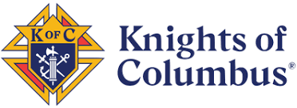St. Jude Council #6617
Est 1974

www.kofc6617.org

Celebrating 50 years
of “Doing Good”
Interested in being part of a great fraternal organization to give back?

Join our Associates Program and receive monthly updates of what’s going on in your Parish & Community.

Contacts:
Grand Knight: Michael Rosa michaelr6617@gmail.com
Membership Director: Dan Sullivan dan49@comcast.net

Name

Address

Email

Phone

I’m interested in becoming a Knight: Yes No Not Sure

I’m interested in becoming an Associate Member: Yes Not Sure

I want to receive the monthly newsletter: Yes No

I want more information before I decide: Yes Not Sure

Are you a Parishioner at St. Luke’s: Yes No
Another Church

